**Practical 6:**

**Objective**: Solving Linear Algebraic Equations

**Part A: MATLAB Matrix Manipulations**

1. Create matrix $A=\left(\begin{matrix}1 & 5 & 6 \\ 7 & 4 & 2 \\ -3 & 6 & 7\end{matrix}\right)$.

A=[1 5 6;7 4 2; -3 6 7]

**octave:1>** A=[1 5 6;7 4 2; -3 6 7]

A =

1 5 6

7 4 2

-3 6 7

1. Find $A^{T}$ (the transpose of $[A]$).

A’

**octave:2>** A'

ans =

1 7 -3

5 4 6

6 2 7

1. Compute the determinant $det⁡(A)$.

det(A)

**octave:3>** det(A)

ans = 65.000

1. Compute $A^{-1}$ (the inverse of $[A]$)

inv(A)

**octave:4>** inv(A)

ans =

0.246154 0.015385 -0.215385

-0.846154 0.384615 0.615385

0.830769 -0.323077 -0.476923

1. Use MATLAB matrix manipulation to solve the following $\left[A\right]\left\{x\right\}=\left\{B\right\}$ problem

$$\left(\begin{matrix}150 & -100 & 0 \\ -100 & 150 & -50 \\ 0 & -50 & 50\end{matrix}\right)\left\{\begin{matrix}x_{1} \\ x_{2} \\ x_{3}\end{matrix}\right\}=\left\{\begin{matrix}588.6 \\ 686.7 \\ 784.8\end{matrix}\right\}$$

**Method1**

A = [150 -100 0; -100 150 -50; 0 -50 50]

B = [588.6; 686.7; 784.8]

X=inv(A)*B

**octave:3>** X=inv(A)*B

X =

41.202

55.917

71.613

**Method2**

Y=A\B

**octave:4>** Y=A\B

Y =

41.202

55.917

71.613

**Part B: Gaussian Elimination and Back Substitution**

The basic idea behind methods for solving a system of linear equations is to reduce them to linear equations involving a single unknown, because such equations are trivial to solve. Such a reduction is achieved by manipulating the equations in the system in such a way that the solution does not change, but unknowns are eliminated from selected equations until, finally, we obtain an equation involving only a single unknown. These manipulations are called elementary row operations, and they are defined as follows:

1. Multiplying both sides of an equation by a scalar
2. Reordering the equations by interchanging both sides of the $i$-th and $j$-th equation in the system.
3. Replacing equation $i$ by the sum of equation $i$ and a multiple of both sides of equation $j$.
4. Using Gaussian Elimination (manually) to solve problem in Part A (Q5)

$$\left(\begin{matrix}150 & -100 & 0 \\ -100 & 150 & -50 \\ 0 & -50 & 50\end{matrix}\right)\left\{\begin{matrix}x_{1} \\ x_{2} \\ x_{3}\end{matrix}\right\}=\left\{\begin{matrix}588.6 \\ 686.7 \\ 784.8\end{matrix}\right\}$$

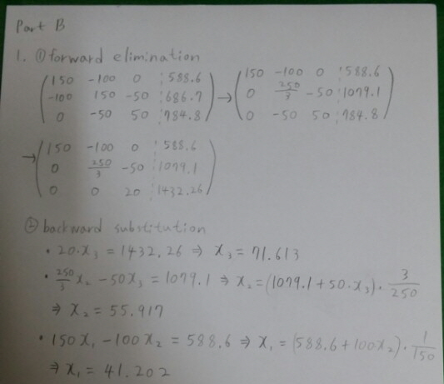

1. Use gaussnaive.m file to verify your answers.

**gaussnaive(A,B)**

**octave:7>** X = gaussnaive(A,B)

Augmented Matrix: Column 1

1.5000e+02 -1.0000e+02 0.0000e+00 5.8860e+02

0.0000e+00 8.3333e+01 -5.0000e+01 1.0791e+03

0.0000e+00 -5.0000e+01 5.0000e+01 7.8480e+02

Augmented Matrix: Column 2

1.5000e+02 -1.0000e+02 0.0000e+00 5.8860e+02

0.0000e+00 8.3333e+01 -5.0000e+01 1.0791e+03

0.0000e+00 7.1054e-15 2.0000e+01 1.4323e+03

X =

41.202

55.917

71.613

**Part C: Gaussian Elimination with Partial Pivoting**

1. Find the entry in the left column with the largest absolute value. This entry is called the **pivot.**
2. Perform a row interchange, if necessary, so that the pivot is in the first row.
3. Divide the first row by the pivot. (This step is unnecessary if the pivot is 1.)
4. Use elementary row operations to reduce the remaining entries in the first column to zero.

The completion of these four steps is called a **pass.** After performing the first pass, ignore the first row and first column and repeat the four steps on the remaining submatrix. Continue this process until the matrix is in row-echelon form.

1. Solve (manually) the following problem using Gaussian Elimination with Partial Pivoting.

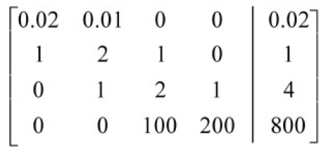

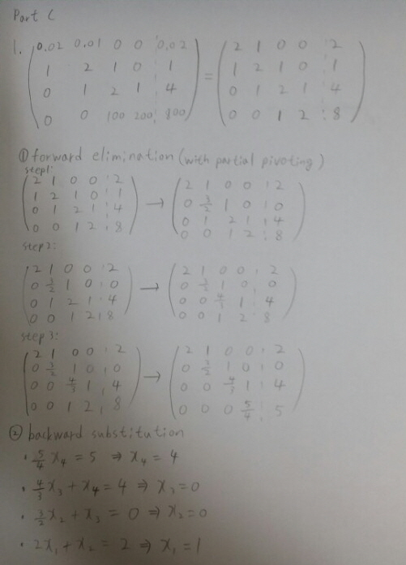

1. Use gausspivot.m file to verify your answers.

gausspivot(A,B)

**octave:7>** X = gausspivot(A,B)

ans =

0.02000

1.00000

0.00000

0.00000

big = 1

i = 2

Augmented Matrix: Column 1

1.00000 2.00000 1.00000 0.00000 1.00000

0.00000 -0.03000 -0.02000 0.00000 0.00000

0.00000 1.00000 2.00000 1.00000 4.00000

0.00000 0.00000 100.00000 200.00000 800.00000

ans =

0.03000

1.00000

0.00000

big = 1

i = 2

Augmented Matrix: Column 2

1.00000 2.00000 1.00000 0.00000 1.00000

0.00000 1.00000 2.00000 1.00000 4.00000

0.00000 0.00000 0.04000 0.03000 0.12000

0.00000 0.00000 100.00000 200.00000 800.00000

ans =

4.0000e-02

1.0000e+02

big = 100

i = 2

Augmented Matrix: Column 3

1.00000 2.00000 1.00000 0.00000 1.00000

0.00000 1.00000 2.00000 1.00000 4.00000

0.00000 0.00000 100.00000 200.00000 800.00000

0.00000 0.00000 0.00000 -0.05000 -0.20000

X =

1

0

0

4

**Part D: Gaussian Jordan Elimination**

Gauss-Jordan Method is a popular process of solving system of linear equation in linear algebra. This method solves the linear equations by transforming the augmented matrix into reduced-echelon form with the help of various row operations on augmented matrix. Gauss-Jordan method is an elimination maneuver and is useful for solving linear equation as well as for determination of inverse of a matrix.

1. Solve (manually) the following problem using Gaussian Jordan Elimination.
$$x+y+2z=8$$

$$-x-2y+3z=1$$

$$3x-7y+4z=10$$

2. Use gauss_jordan_elim.m file to verify your answer.

gauss_jordan_elim(A,B)

**octave:4>** X = gauss_jordan_elim(A,B)

X =

3

1

2

**Part E: Cramer’s Rule**

In [linear algebra](https://en.wikipedia.org/wiki/Linear_algebra), Cramer's rule is an explicit formula for the solution of a [system of linear equations](https://en.wikipedia.org/wiki/System_of_linear_equations) with as many equations as unknowns, valid whenever the system has a unique solution. It expresses the solution in terms of the [determinants](https://en.wikipedia.org/wiki/Determinant) of the (square) coefficient [matrix](https://en.wikipedia.org/wiki/Matrix_(mathematics)) and of matrices obtained from it by replacing one column by the vector of right hand sides of the equations.

1. Write a Cramer’s Rule program to solve any given system of linear equation in three variables: $ax+by+cz=d$.
2. Use your program to verify the following system:

$$-3x_{2}+7x_{3}=2$$

$$x_{1}+2x_{2}-x_{3}=3$$

$${5x}_{1}-2x_{2}=2$$

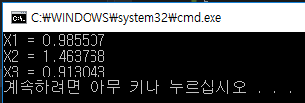

**Part F: Some Applications Systems of Linear Equations**

1. A gas station sells three types of gas:

* *Regular for $2.80/gallon x*
* *Performance for $3.00/gallon y*
* *Premium for $3.20/gallon z*

On a particular day, 3900 gallons of gas were sold for a total of $11,460. Two times as many gallons of Regular as Premium gas were sold. How many gallons of each type of gas were sold that day?

Regular : 2400 gallon, Performance : 300 gallon, Premium : 1200 gallon

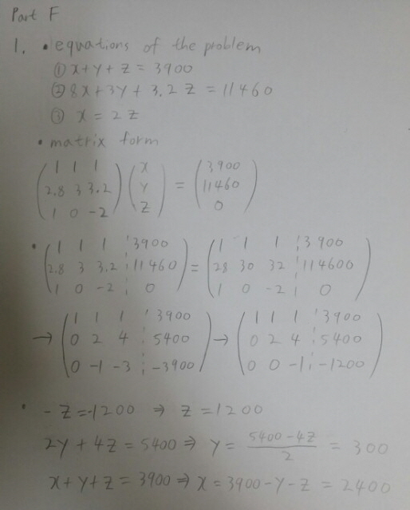

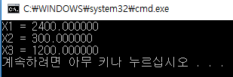

1. An investor has $126,000 to invest in three types of bonds: short-term, intermediate-term, and long-term. How much should she invest in each type to satisfy the given conditions?

* *Short-term bonds pay 4% annually, intermediate-term bonds pay 5% and long-term bonds pay 6%. The investor wishes to realize a total annual income of 5%, with equal amounts invested in short- and intermediate-term bonds. (Round your answers to the nearest thousand)*

short : $42000, intermediate: $42000, long : $42000

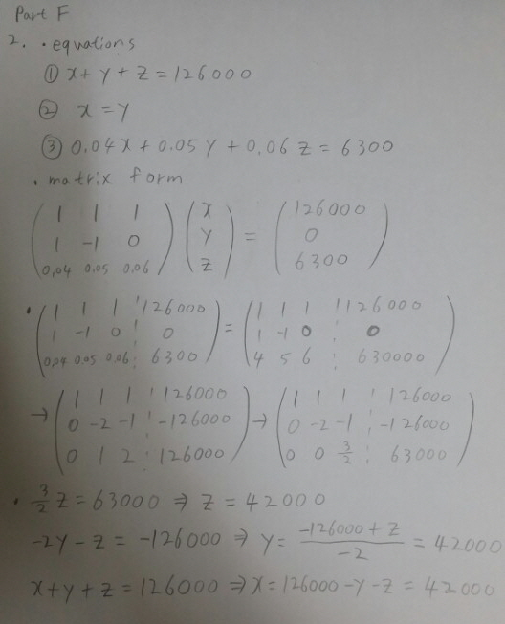

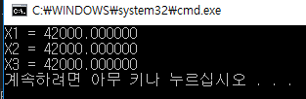

1. Find the flow rate of cars on each segment of streets based on the following observations:

* Flow into an intersection = flow out of that intersection
* Total flow in = total flow out

